SPSR
R14
R0
R1
R3
R2
R4
R6
R5
R7
R8
R9
R10
R11
R12
R14
R13
R15
CPSR
normal mode interrupt mode
M = 0 M = 1
SP
LR
PC
15 0
N
15 7 6 5 4 3 2 1 0
Z
C
V
unused
I
M
Mode
Interrupt enable
Negative
Overflow
Carry / Borrow
Zero
xPSR

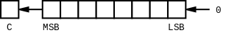  lsl rd, rn, imm4 | 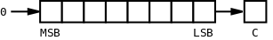  lsr rd, rn, imm4
asr rd, rn, imm4  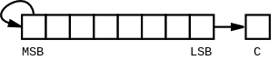 | 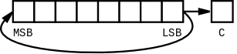  ror rd, rn, imm4
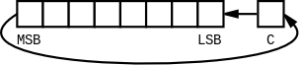  adc rd, rn, rn | 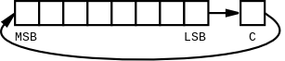  rrx rd, rn

